Lab Assignment 3

[**Edit**](https://github.com/madhurisarda/ASE/wiki/Lab-Assignment-3/_edit)[**New Page**](https://github.com/madhurisarda/ASE/wiki/_new)Jump to bottom udaya byreddy edited this page now · [3 revisions](https://github.com/madhurisarda/ASE/wiki/Lab-Assignment-3/_history)

Lab Assignment 3

Name: Udaya Byreddy ID: 16293204 Class ID: 3 Lab ID: 6_2

In agenda of this assignment is

1. To create a login and register page and store the values in local storage of the browser and while login we must authenticate the user by getting the values from local storage.
2. If the username and password are valid User will be taken to the next page of search food where we are calling 2 API's Nutritionix and ResponsiveVoice API.
3. Using Nutritionix API we are sending a food item which the user enters in the text box and when we click on go we hit the API using unique AppID and API key and get the data and using Typescript we iterate over the data and get the values that we need like calories and serving weight in grams.
4. Using the text to speech API ResponsiveVoice, we are converting the results in speech format.

The link to the document with the code snippet is

[<https://github.com/udayabyreddy/ASE/tree/master/LAB-3/Lab3_NutritionChecker>/SourceCodeDocu ment.docx](https://github.com/udayabyreddy/ASE/blob/master/Lab3_NutritionChecker/SourceCodeDocu%20ment.docx)

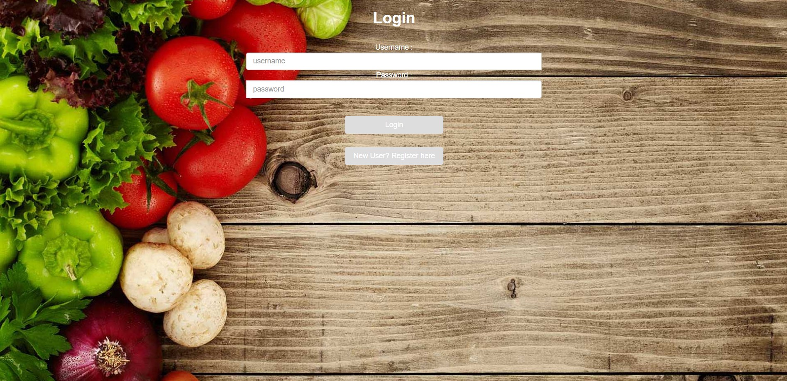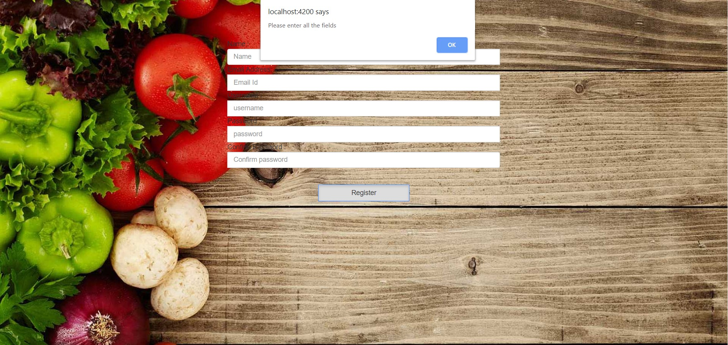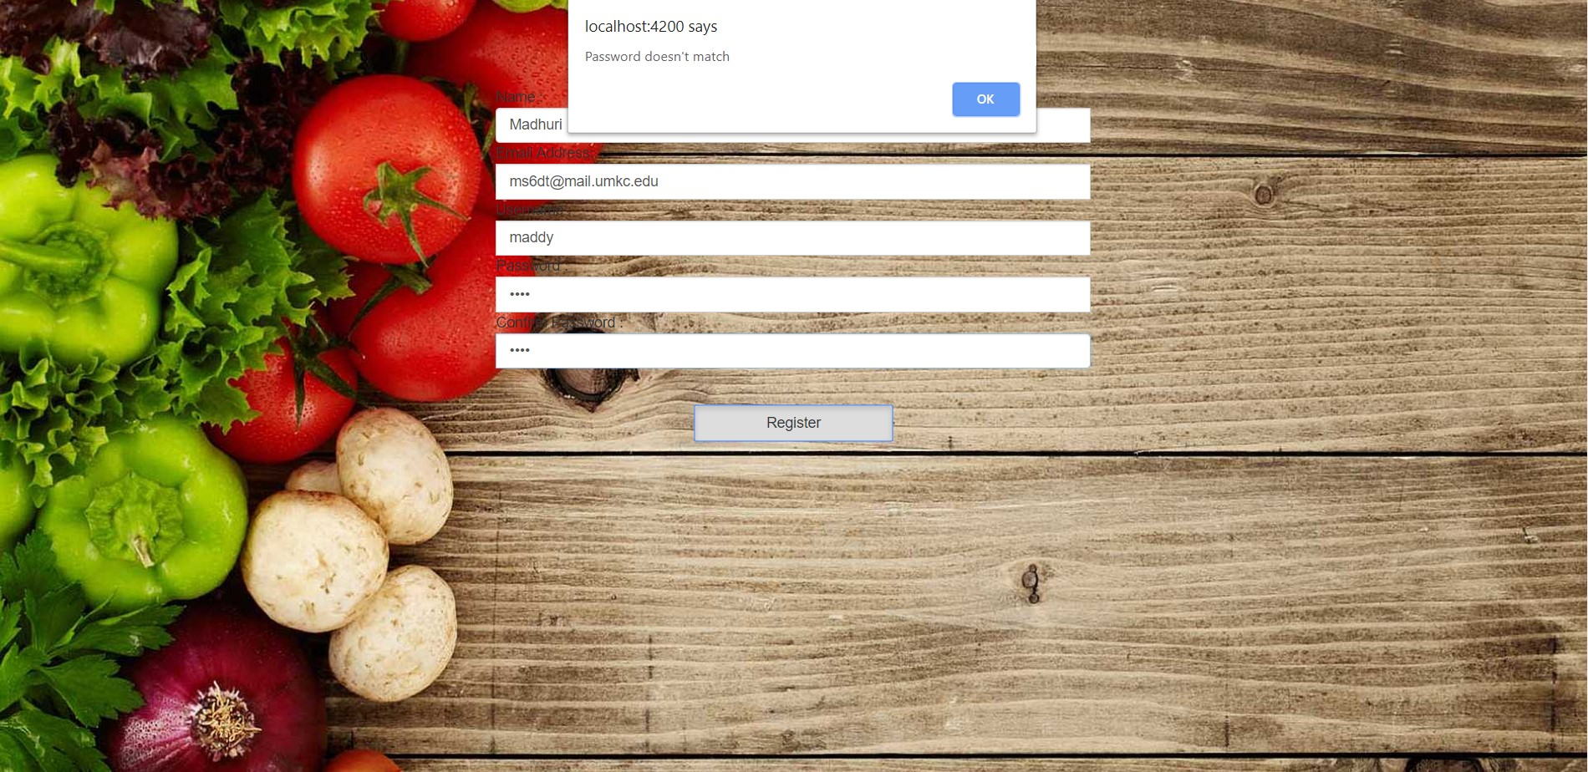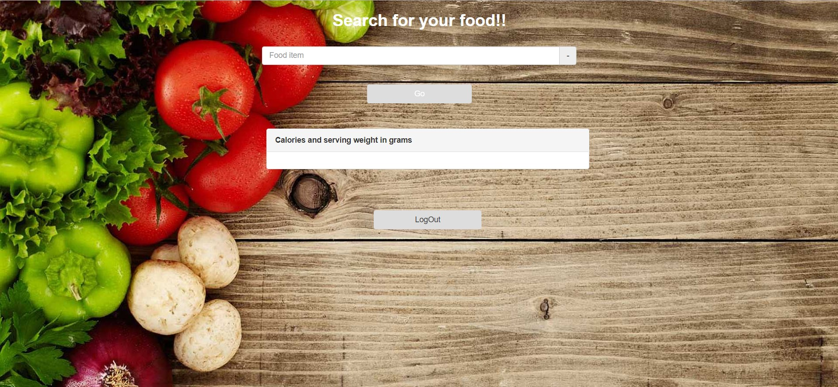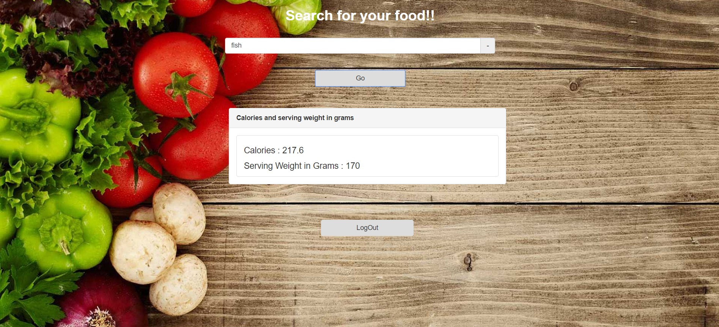

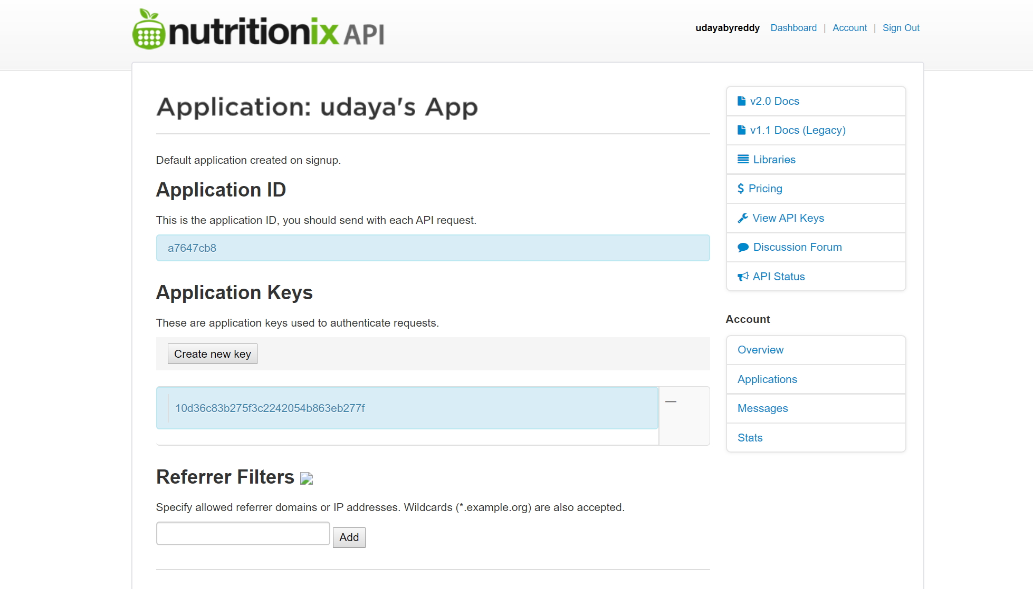

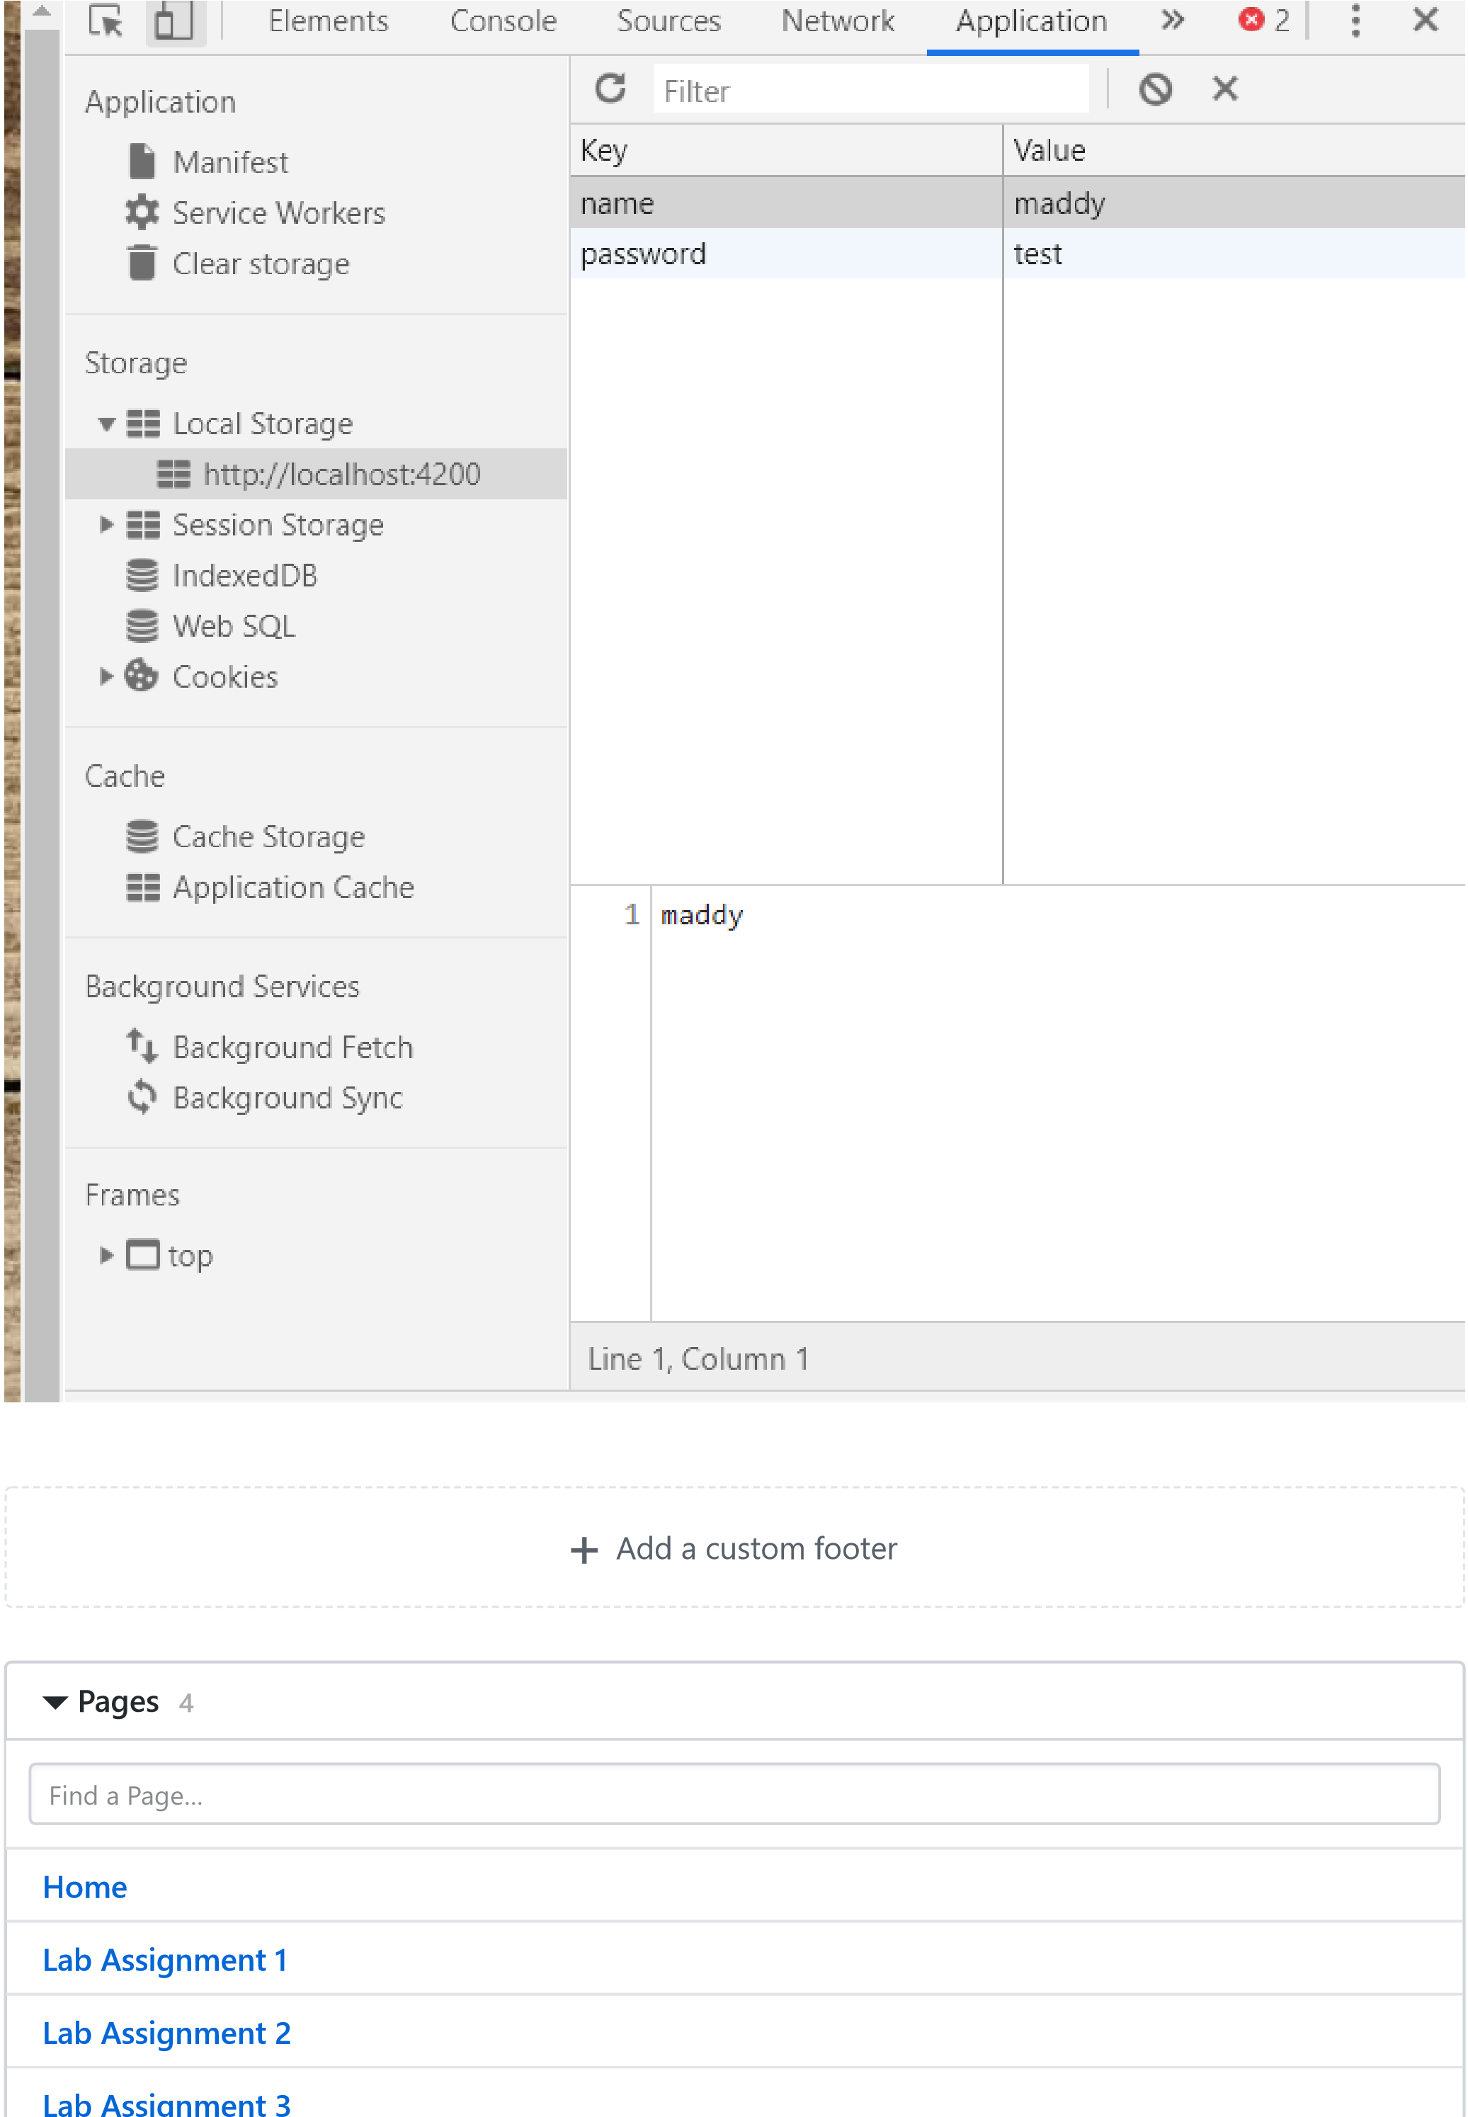

**ab ss g e t 3**



**Clone this wiki locally**

https://github.com/udayabyreddy/ASE